SELECTION OF NURSING INSTITUTES AS “HUBS” FOR FACULTY DEVELOPMENT PROGRAM
The {Mention Department of Medical Education and Training} is committed to improving the quality of Nursing Education in {Mention state}. In this regard, {Mention state nursing council} invites interested nursing institutes to self-nominate themselves as HUBS for conducting Faculty Development Programs.
What will be expected of the nursing Institutes:
- Undergo an inspection visit by JHPIEGO (Johns Hopkins Program for International Education in Gynecology and Obstetrics) < mentioned as example > on pre-defined performance standards basis which shortlisting for HUBS will take place
- If shortlisted as HUBS the nursing institute will be required to:
  - Deploy 2 dedicated faculty for this program who shall be trained by JHPIEGO < mentioned as example >
  - Conduct classroom-based training and faculty development programs for other nursing colleges
The benefits to the selected HUBS would be:
- Recognition by {Mention state nursing council} as one of the best quality Nursing Institutes in {Mention state} and receive support from Technical Experts for conducting Faculty Development Programs
- Prescribe fee for the Nursing Faculty Development Programs as deemed fit subject to such rules and regulations of {Mention state nursing council} notified from time to time
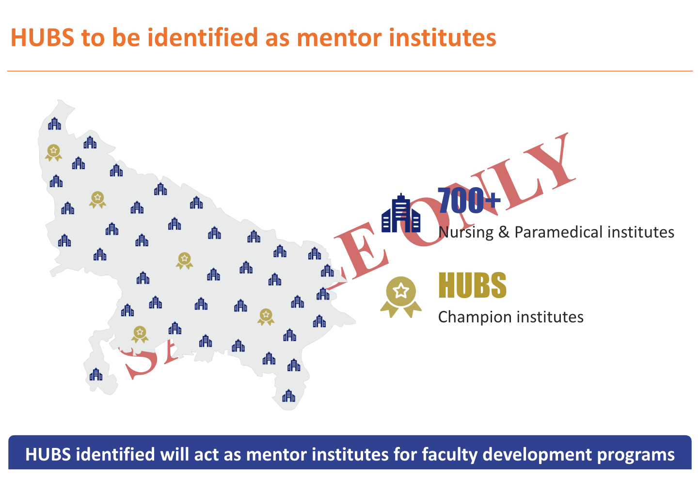
- Incentives during affiliation process for new courses or increase in batch size for existing courses
In order to express interest, contact the undersigned by {Mention date}

Sh XYZ
Sr. Assistant
Ph No.: 94XXXXXXXX
Email: xyz@gmail.com

